SAVEETHA SCHOOL OF ENGINEERING

SAVEETHA INSTITUTE OF MEDICAL AND TECHNICAL SCIENCES

INSTITUTE OF CSE

CSA1514- CLOUD COMPUTING AND BIG DATA ANALYTICS

NAME: M.Greeshma
REG NO: 192524195
FACULTY:Dr.Latha

- Flight Reservation System
Aim
To develop a simple Cloud-based Flight Reservation System using a Cloud Service Provider to demonstrate the Software as a Service (SaaS) model, allowing users to search and reserve domestic and international flights by entering travel details.
Procedure
- Select a Cloud Service Provider such as AWS, Microsoft Azure, or Google Cloud.
- Create and configure a cloud-based application environment.
- Design the Flight Reservation System interface with the following fields:
  - Trip Type: One Way / Round Trip
  - From: Departure city/airport
  - To: Destination city/airport
  - Departure Date
  - Return Date for round trips
  - Travelers: Adults, Children, Infants
  - Class: Economy, Premium Economy, Business, First Class
  - Fare Type: Regular, Student, Senior Citizen, Armed Forces, etc.
  - Flight Type: Domestic / International
- Add a Search Flights button to process the entered details.
- Display suitable flight details such as airline, departure time, arrival time, duration, and fare.
- Allow the user to select a flight and enter basic passenger details.
- Provide a Book/Reserve Flight option and display a booking confirmation.
- Deploy the application on the selected cloud platform so that it can be accessed through the internet as a SaaS application.
- Test the application by performing domestic and international, one-way and round-trip searches.
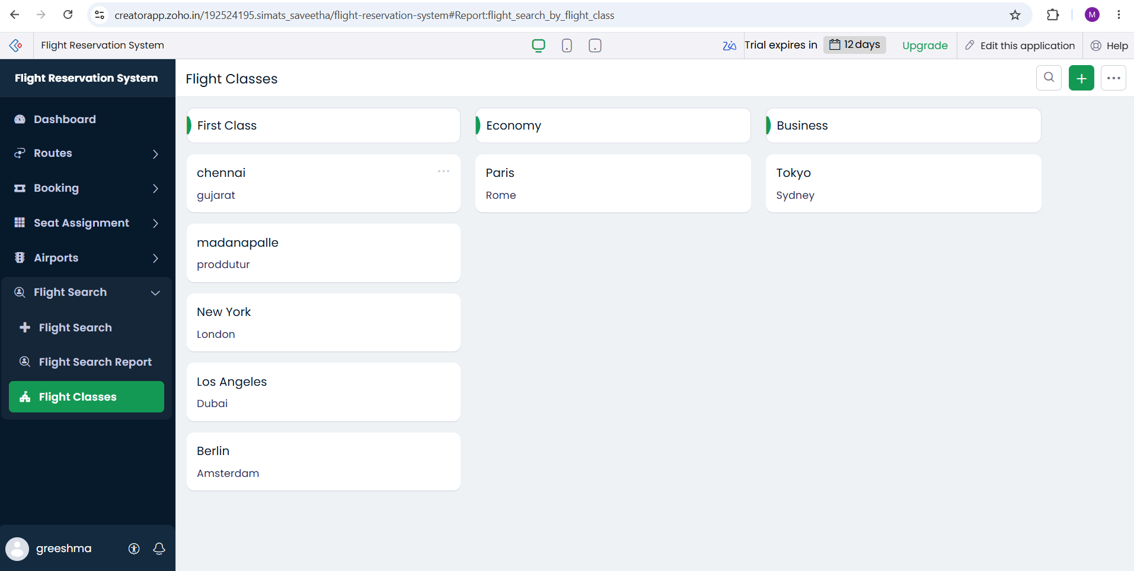
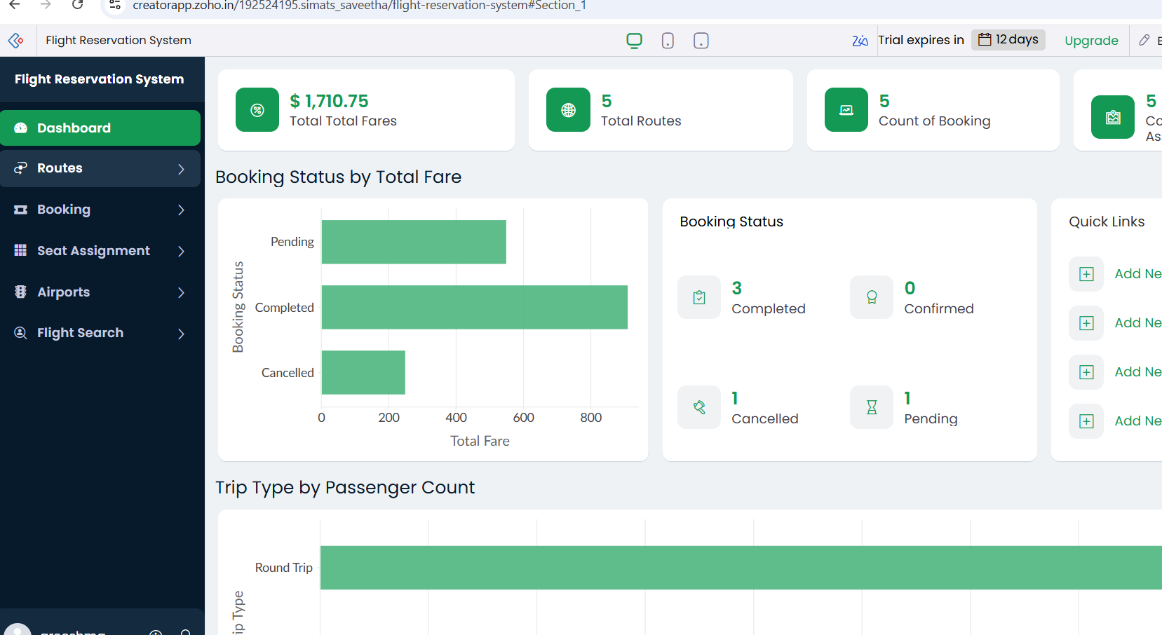

Result
Thus, a Cloud-based Flight Reservation System was successfully developed and deployed using a Cloud Service Provider. The application supports one-way and round-trip bookings, domestic and international flights, source and destination selection, travel dates, travelers, class, and fare type, demonstrating the SaaS model.

- Property Buying and Rental System for Chennai
Aim
To develop a simple Cloud-based Property Buying and Rental System for Chennai using a Cloud Service Provider to demonstrate the Software as a Service (SaaS) model, enabling users to search, buy, or rent residential and commercial properties based on their requirements.
Procedure
- Select a Cloud Service Provider such as AWS, Microsoft Azure, or Google Cloud.
- Create and configure a cloud-based environment for the property application.
- Design the application interface with the following fields:
  - Transaction Type: Buy / Rent
  - Property Type: Residential / Commercial
  - Property Option: Apartment / Villa / Independent House / Office / Shop
  - Place/Location: Chennai areas such as Velachery, Tambaram, Anna Nagar, Adyar, etc.
  - Area: Property size in sq. ft.
  - Budget/Range: Minimum and maximum price
  - Property Value: Total property price or monthly rent
  - Bedrooms: 1 BHK, 2 BHK, 3 BHK, etc.
  - Rental Agreement: Required / Not Required
- Add a Search Property button to process the user's requirements.
- Display matching properties with details such as location, area, property type, price/rent, and availability.
- Allow users to select a property and view complete property details.
- For rental properties, provide a Rental Agreement option.
- For properties available for purchase, provide a Buy/Contact Owner option.
- Store property and user details in a cloud database.
- Deploy the application on the selected cloud platform so that users can access it through the internet as a SaaS application.
- Test the system using different Chennai locations, property types, budgets, and Buy/Rent options.

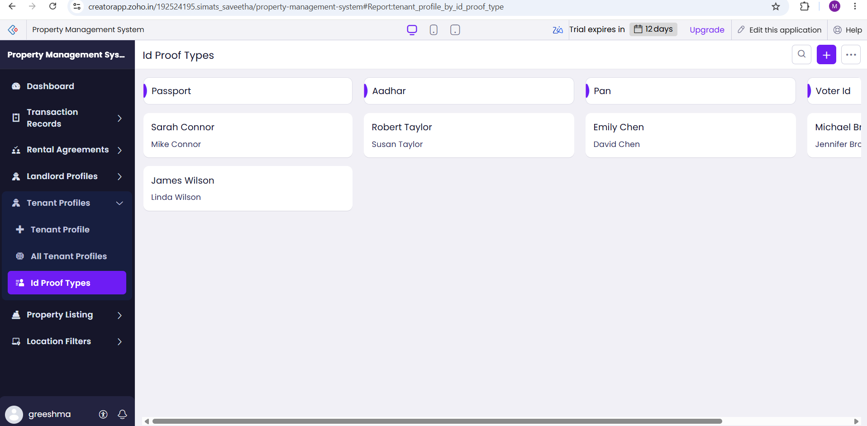
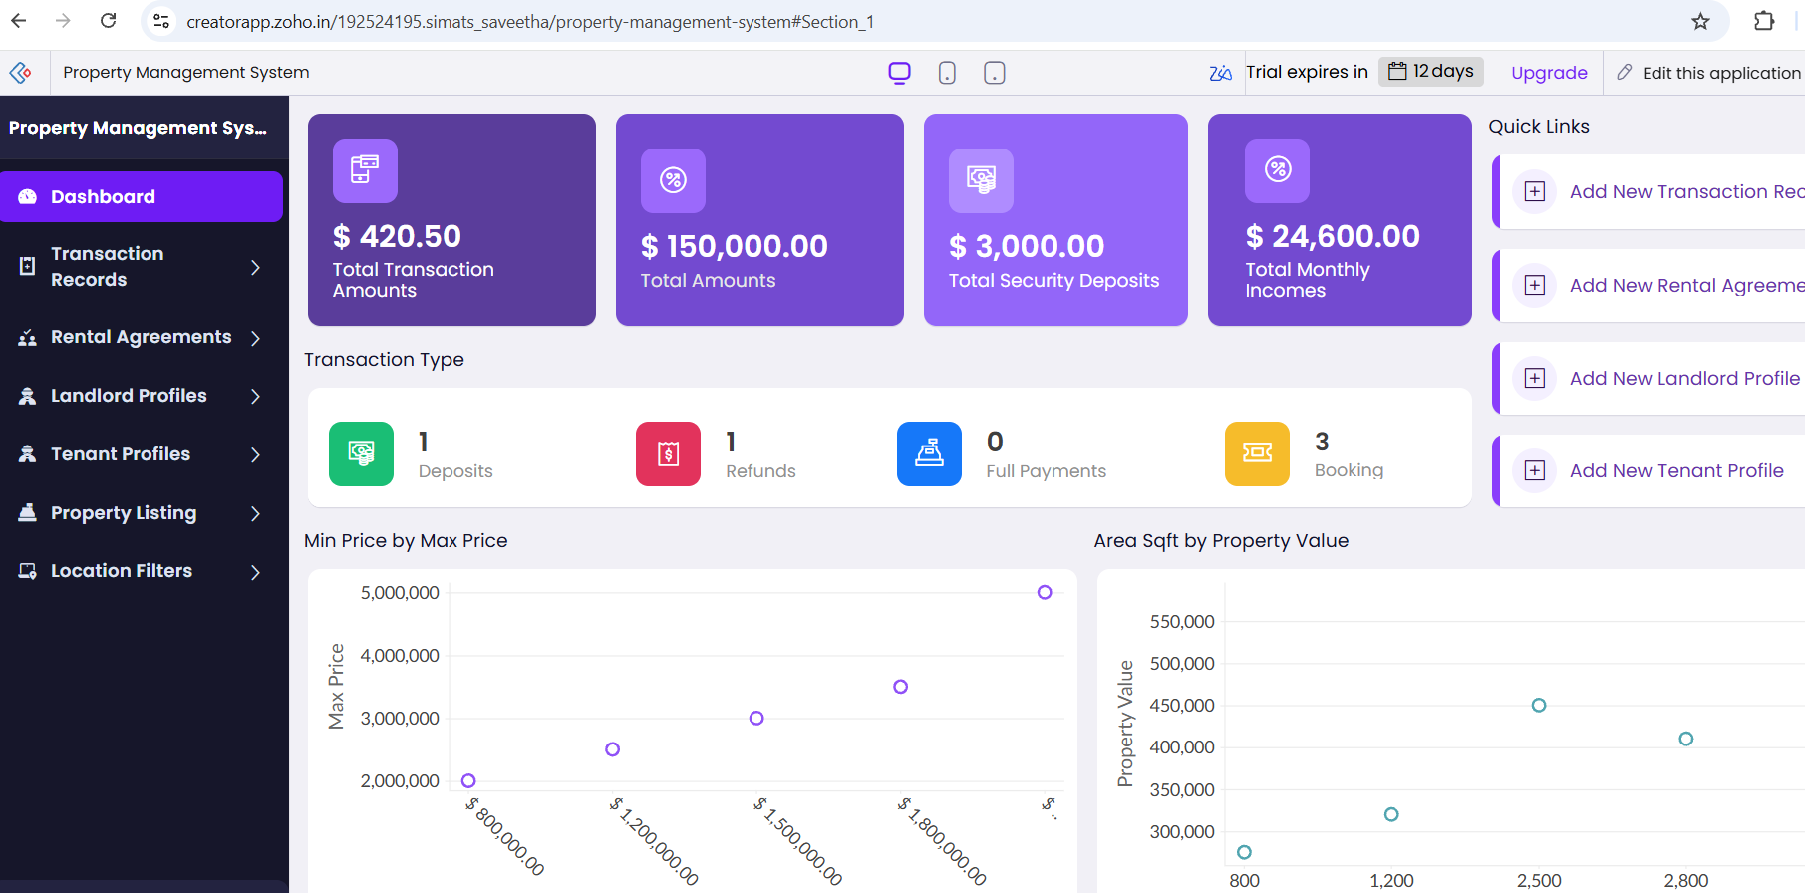

Result
Thus, a Cloud-based Property Buying and Rental System for Chennai was successfully developed and deployed using a Cloud Service Provider. The application allows users to buy or rent residential and commercial properties by specifying location, area, price range, property value, and rental agreement requirements, thereby demonstrating the SaaS model.

- Car Booking Reservation System
Aim
To develop a simple Cloud-based Car Booking Reservation System using a Cloud Service Provider to demonstrate the Software as a Service (SaaS) model, allowing users to search and book cabs for local travel, rental, outstation trips, and package-based services.
Procedure
- Select a Cloud Service Provider such as AWS, Microsoft Azure, or Google Cloud.
- Create and configure a cloud-based environment for the car booking application.
- Design the application interface with the following fields:
  - Booking Type: Cab / Rental / Outstation
  - From: Pickup location
  - To: Destination
  - Date and Time: Pickup date and time
  - Package Type: Hourly / Daily / Outstation
  - Duration: Number of Hours / Days
  - Car Type: Mini / Sedan / SUV
  - Number of Passengers
  - Trip Type: One Way / Round Trip
- Add a Search Cabs button to process the entered travel details.
- Display available cabs with details such as car type, seating capacity, estimated fare, and availability.
- Allow the user to select a suitable cab and enter basic booking details.
- Calculate and display the estimated booking fare based on distance, hours, or days.
- Provide a Book Now option and display a booking confirmation after successful reservation.
- Store booking and customer details in a cloud database.
- Deploy the application on the selected cloud platform so that it can be accessed through the internet as a SaaS application.
- Test the application using local cab, rental, and outstation booking scenarios.

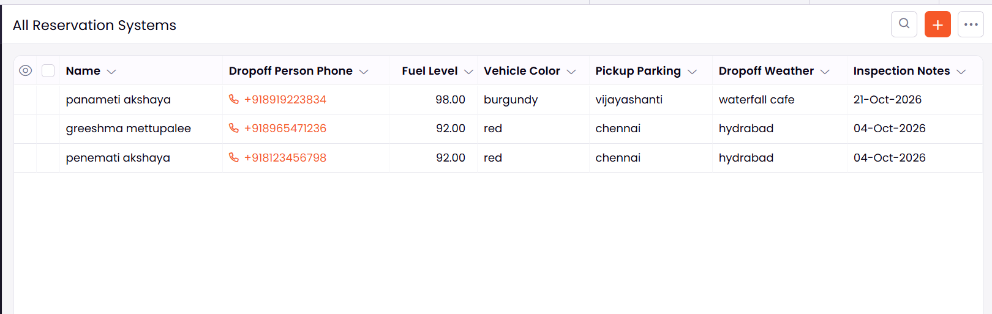
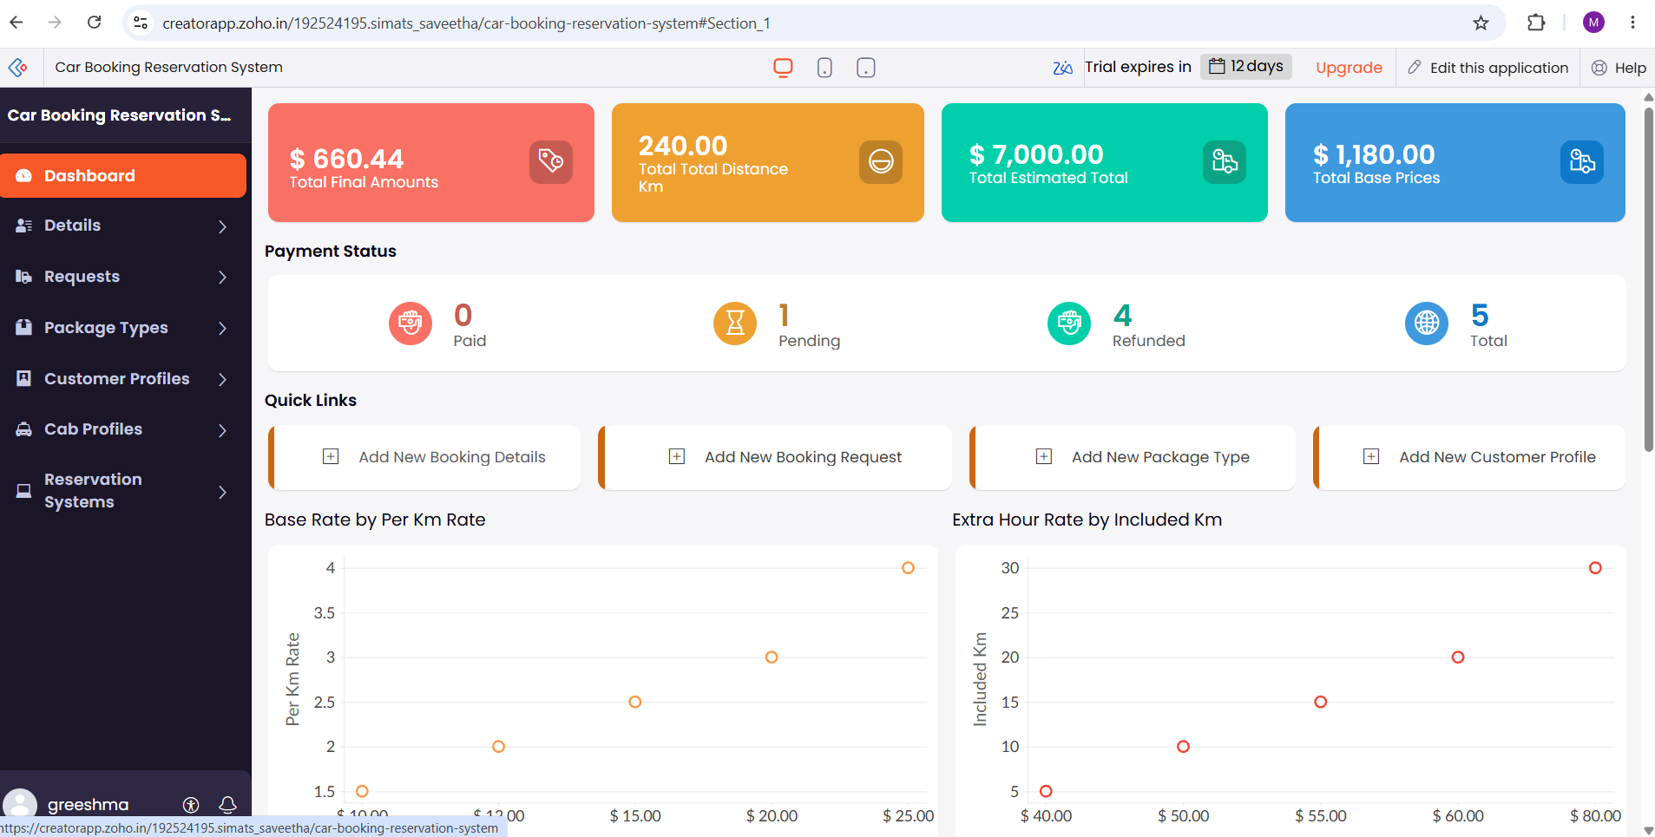

Result
Thus, a Cloud-based Car Booking Reservation System was successfully developed and deployed using a Cloud Service Provider. The application allows users to search and book cabs for local, rental, and outstation trips by specifying pickup and destination locations, package type, hours/days, and car type, thereby demonstrating the SaaS model.

- Library Book Reservation System
Aim
To develop a simple Cloud-based Library Book Reservation System for SIMATS Library using a Cloud Service Provider to demonstrate the Software as a Service (SaaS) model, allowing students and staff to search, reserve, and manage library books online.
Procedure
- Select a Cloud Service Provider such as AWS, Microsoft Azure, or Google Cloud.
- Create and configure a cloud-based environment for the library application.
- Design the application interface with the following fields:
  - Book Title
  - Author Name
  - Publication
  - Year of Publication
  - Edition
  - Number of Copies
  - Rack Number
  - Book ID
  - Status: Available / Taken / Returned
  - Student/Staff ID
  - Reservation Date
- Create a cloud database to store book and reservation details.
- Provide a Search Book option to find books using title, author, publication, or book ID.
- Display the selected book's details, including availability, number of copies, and rack number.
- Allow users to reserve an available book using their Student/Staff ID.
- Update the book status automatically when a book is taken, returned, or reserved.
- Provide an option for the librarian to add, update, or remove book records.
- Deploy the application on the selected cloud platform so that students and staff can access it through the internet as a SaaS application.
- Test the system by searching for books, making reservations, issuing books, and updating their return status.

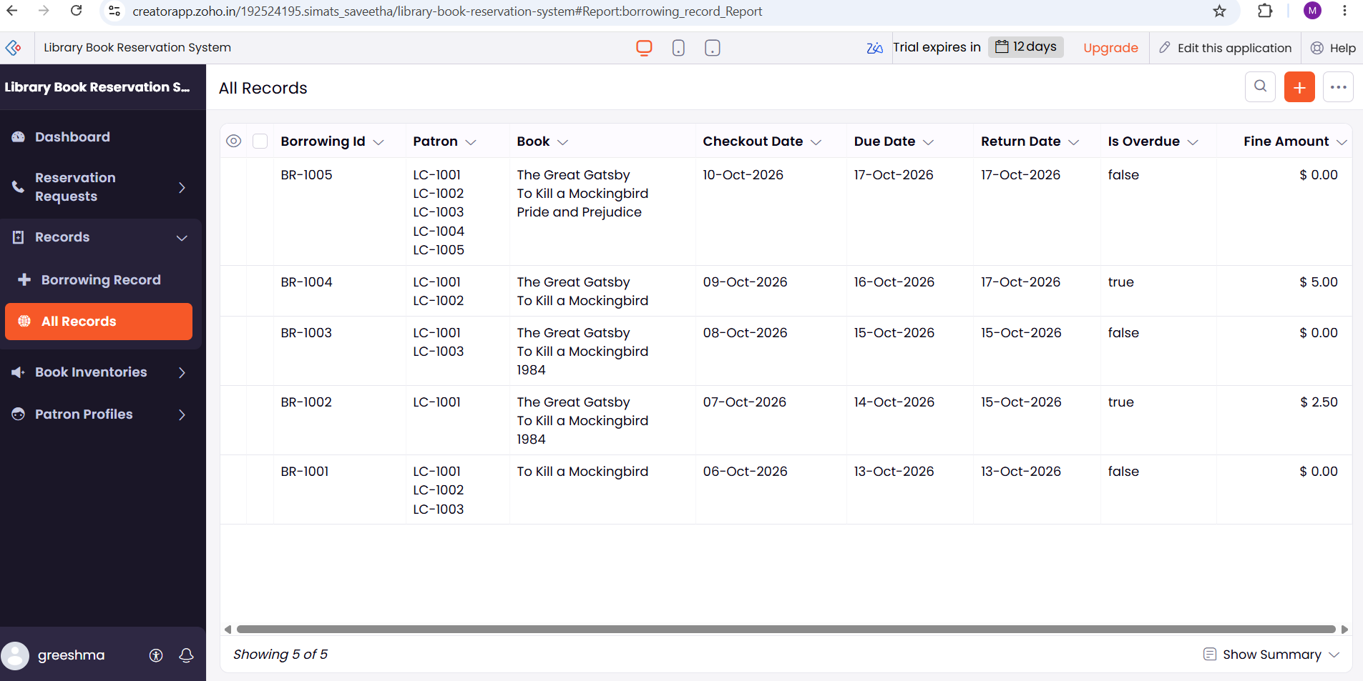
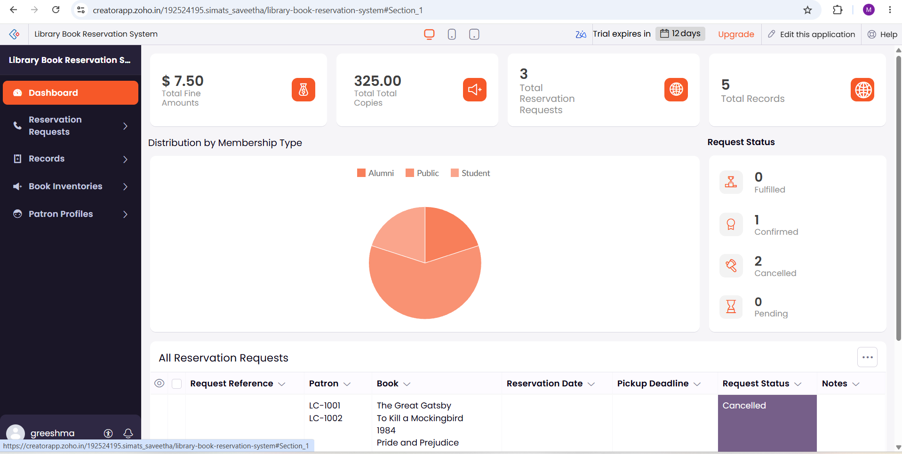

Result
Thus, a Cloud-based Library Book Reservation System for SIMATS Library was successfully developed and deployed using a Cloud Service Provider. The system enables users to search and reserve books and allows librarians to manage book details, copies, rack numbers, and availability status, thereby demonstrating the SaaS model.

